Parents, welcome to Schoology! This step by step guide will show you how to access information on the Schoology Platform about your child’s courses and instruction. To create an account, please complete the Schoology account slip that was available at iPad pickup and open house. If you did not receive one, please contact the school to obtain one. Once you have received your login information, you can begin at Step 1.
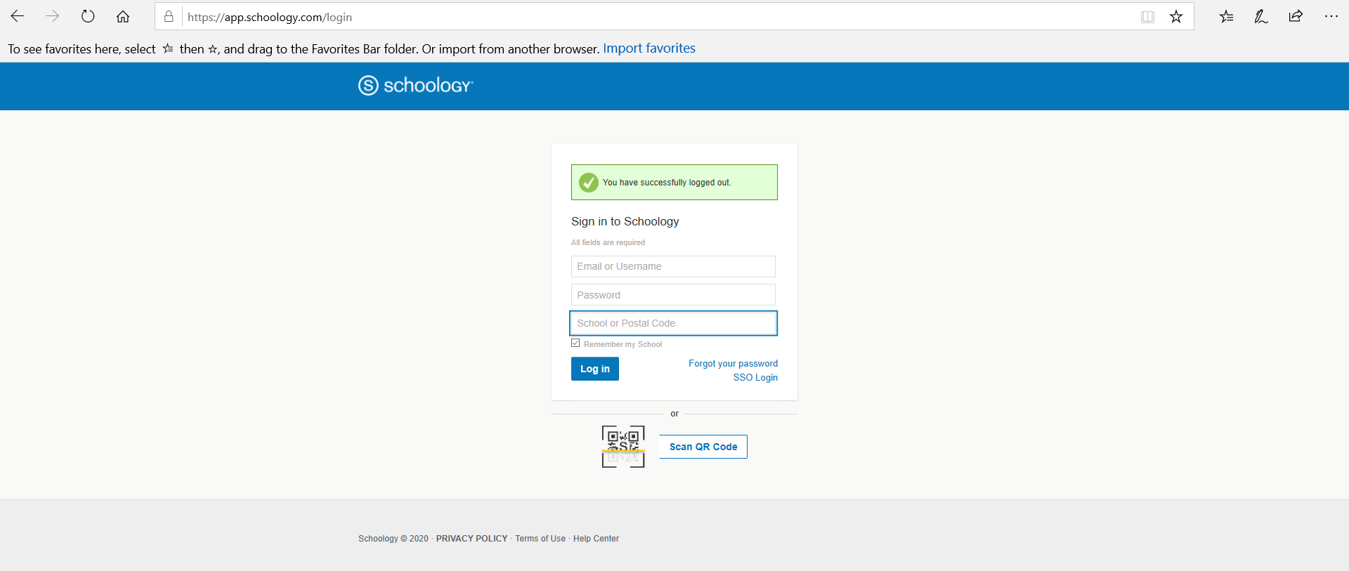
Step 1: When you receive your login credentials, you will go to the website: https://app.schoology.com/login The screen is shown below.

Step 2: Enter the following information:
Your username
Your password
Zip code: 15424
Select Turkeyfoot Valley Area School District
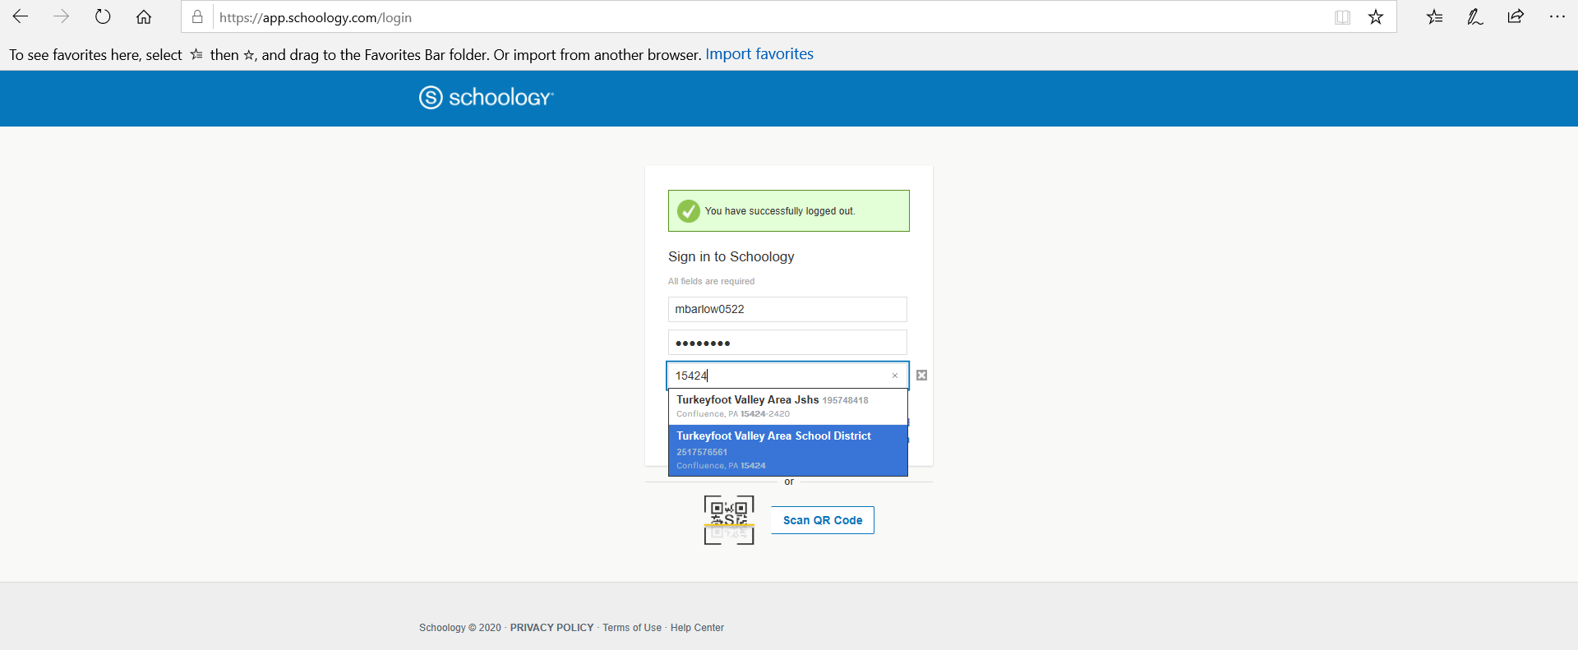
The login screen will look like this:
Make sure you click on the “Turkeyfoot Valley Area School District”
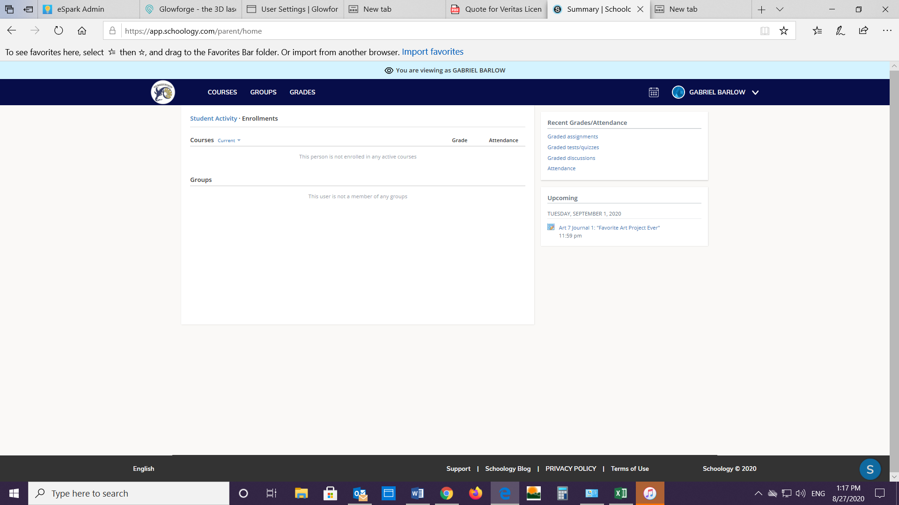
Step 3: After clicking on login, you will see the following screen. You can start to explore the site in the following steps.
Click on COURSES to see your child’s classes.
Look here to see any upcoming assignments due in your child’s courses.
Click here to look at the course work for a different child or to switch to your homepage.

Step 4: By clicking on COURSES you can see the classes your child is enrolled in. Click on the class you would like to see. In this example only one class is shown.
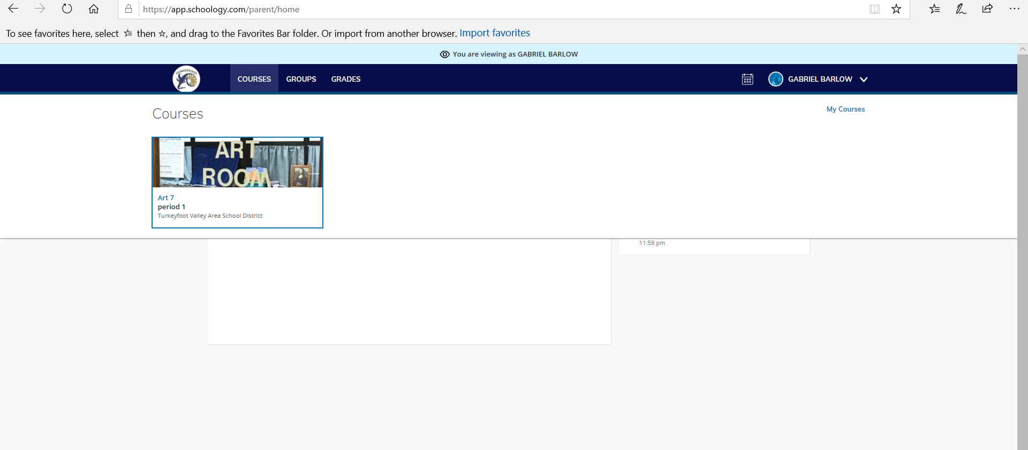
Click on the course picture to see the class information.

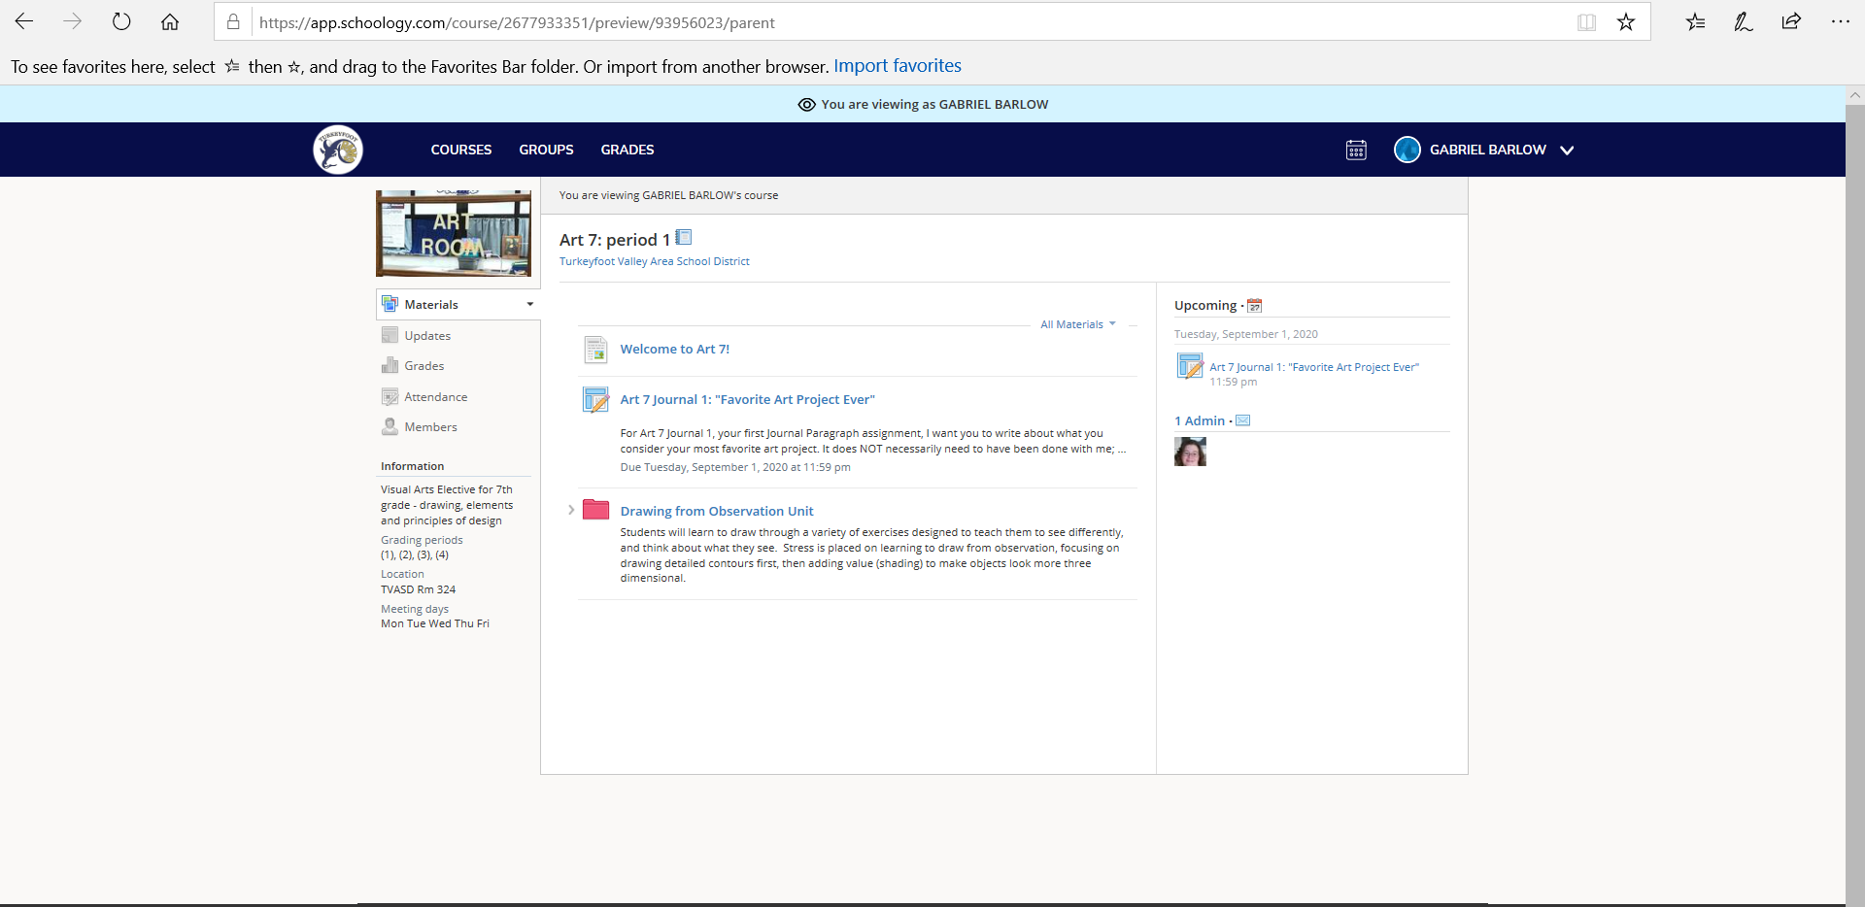
Step 5: This is the class page. Here students will see their assignments and resources needed to complete the assignments. The teachers will provide instruction through materials posted to this page. Click the logo in the upper left to return to the homepage.
Click here to return to the student homepage.
Course materials will be here.

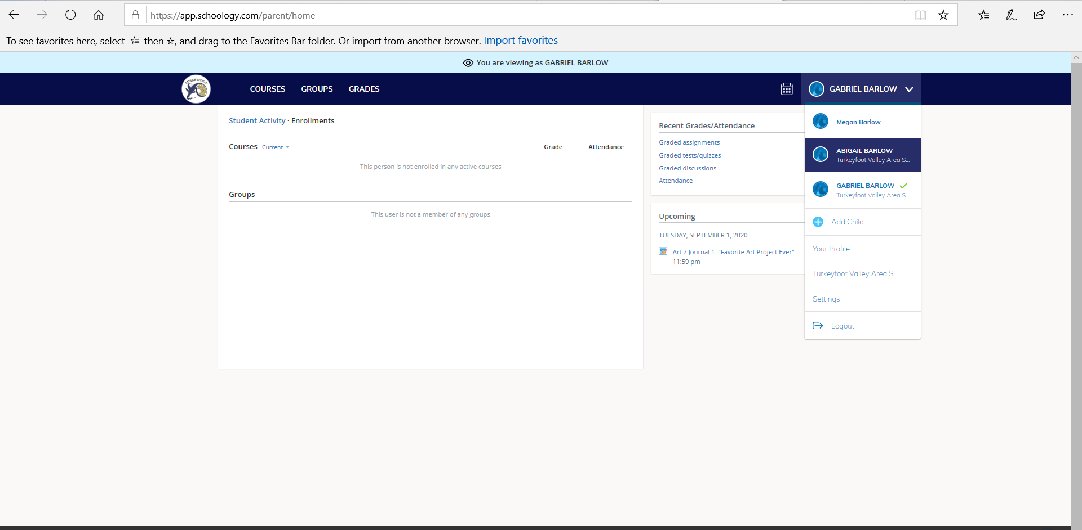
Step 6: Click on the name of your child to see the drop down box. Here you can select another child in order to view their courses. After clicking the child’s name, simply repeat steps 3-5.
Click on other children’s names to see their classes.

Click here and select your name.
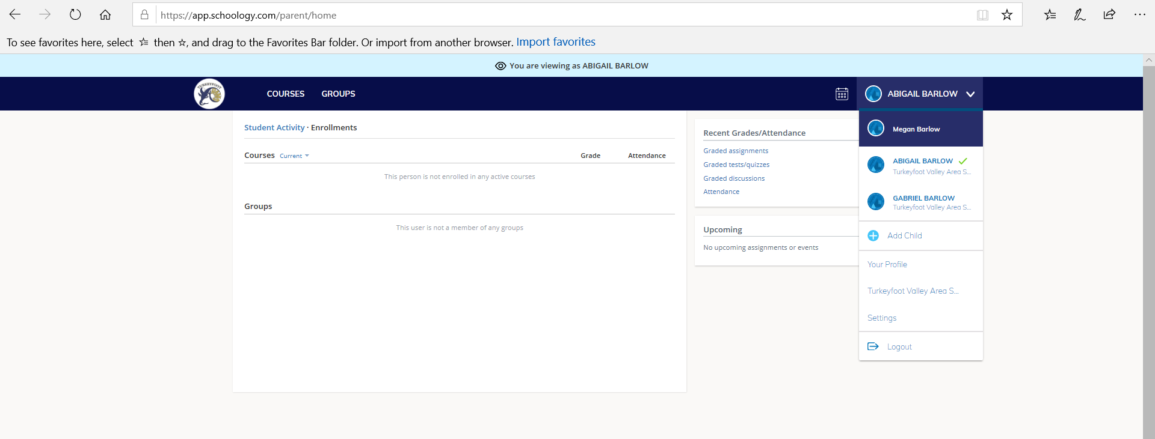
Step 7: Next, click on your child’s name and select your name from the drop down. This takes you to your homepage. From here you can communicate with your child’s teacher.
Click here and select your name.

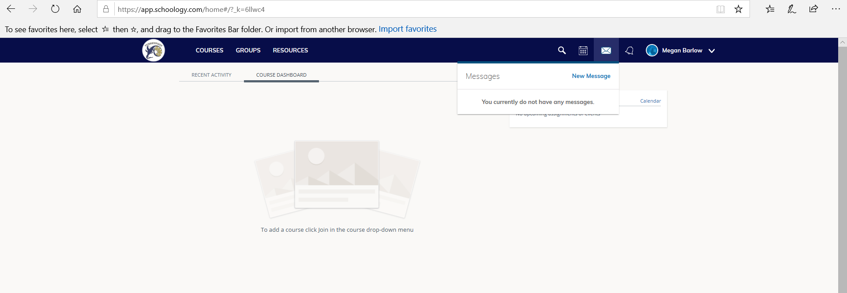
Step 8: On your home page, click the envelope in the upper right. Here you can send a message to your child’s teacher. You will click “new message” and type their name in. It will populate the teacher’s name. Click on it and send your message. Check here often for teacher’s messages.
Click here to view and send messages to teachers.

This concludes our introduction to Schoology. There are other features in the platform for you to explore, but the steps outlined here are most critical for working in the platform. These steps will help you monitor your child’s progress through their instruction. Grades for assignments will be posted in the GoEdustar grading system. To obtain a parent account, please contact the school for a form. These forms will be available at Open House as well.

If you have questions or would like to set up a one to one meeting to learn about the program, please call the school at 814-396-3621 and leave a message for Mrs. Barlow at extension 208. She will set up a time and date to meet with you.
Students, welcome to Schoology! This online platform will be used to access materials while you are learning remotely. This guide will explain the basic features you will need to access materials. Your teachers will provide more information. Also, your grades for work will be posted in GoEdustar, not this platform. If you would like access to GoEdustar, please contact the school for an enrollment form.

In order to start using Schoology you will need your login information. It will be supplied with your iPad. It will have a username and password. You will also need access codes for each class you are taking. Your teachers will provide these with their materials. Once you have all this information you can start at Step 1 of this guide.

Step 1: Go to the website: https://app.schoology.com/ Go to the login page and enter your username, password, and type in 15424 for the zip code. Select The Turkeyfoot Valley Area School District when the drop down choice appears. Click login.
Make sure you click on the “Turkeyfoot Valley Area School District”

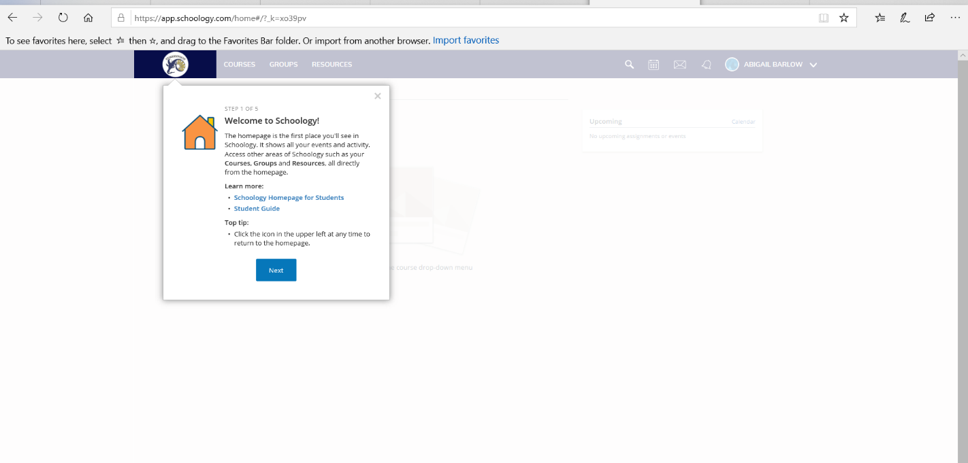
Step 2: You will see your initial homepage. Click through the pop ups that explain some of the features.

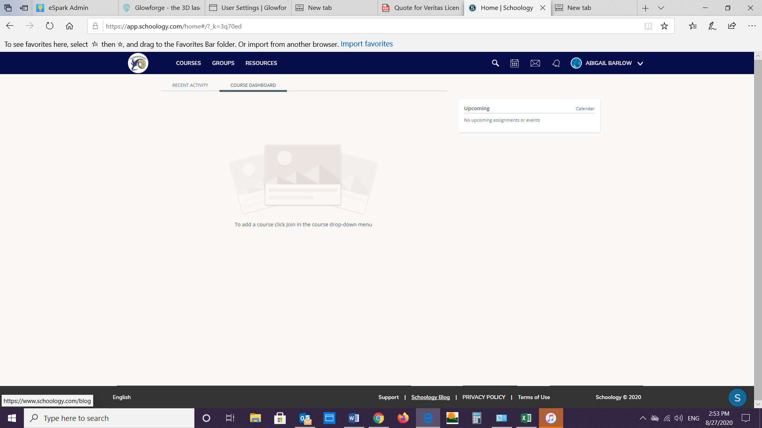
Step 3: Welcome to the homepage. From here you will click COURSES. And once you click it, click join courses. You will then enter the access code provided by your teacher. Click “Join”.

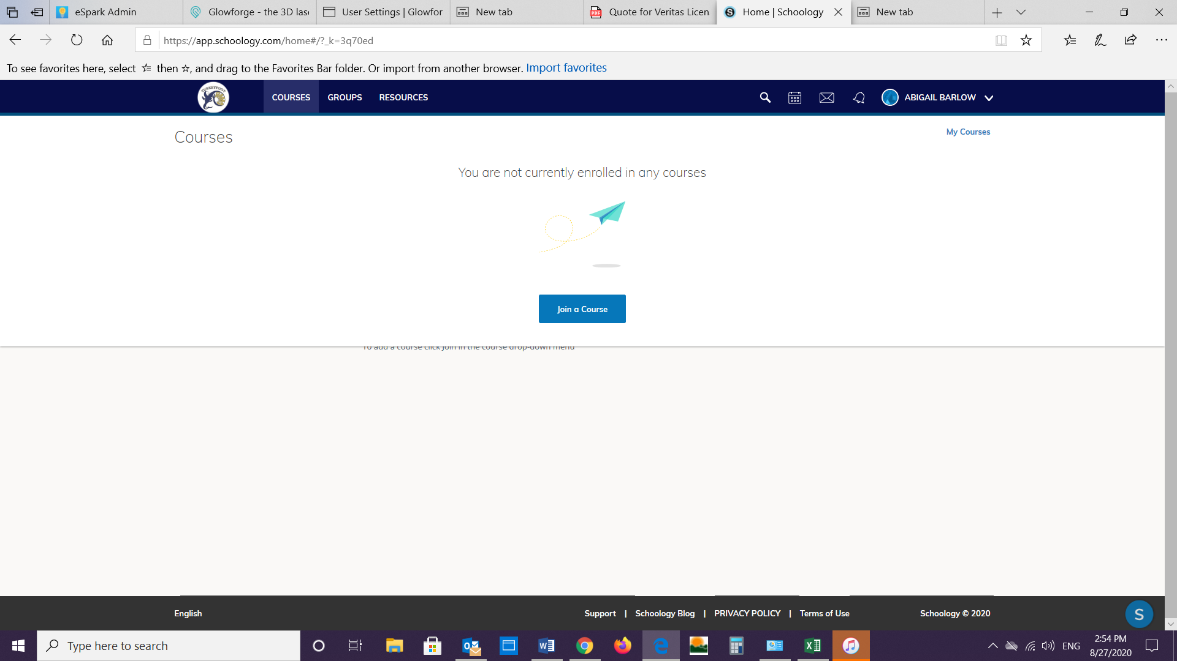

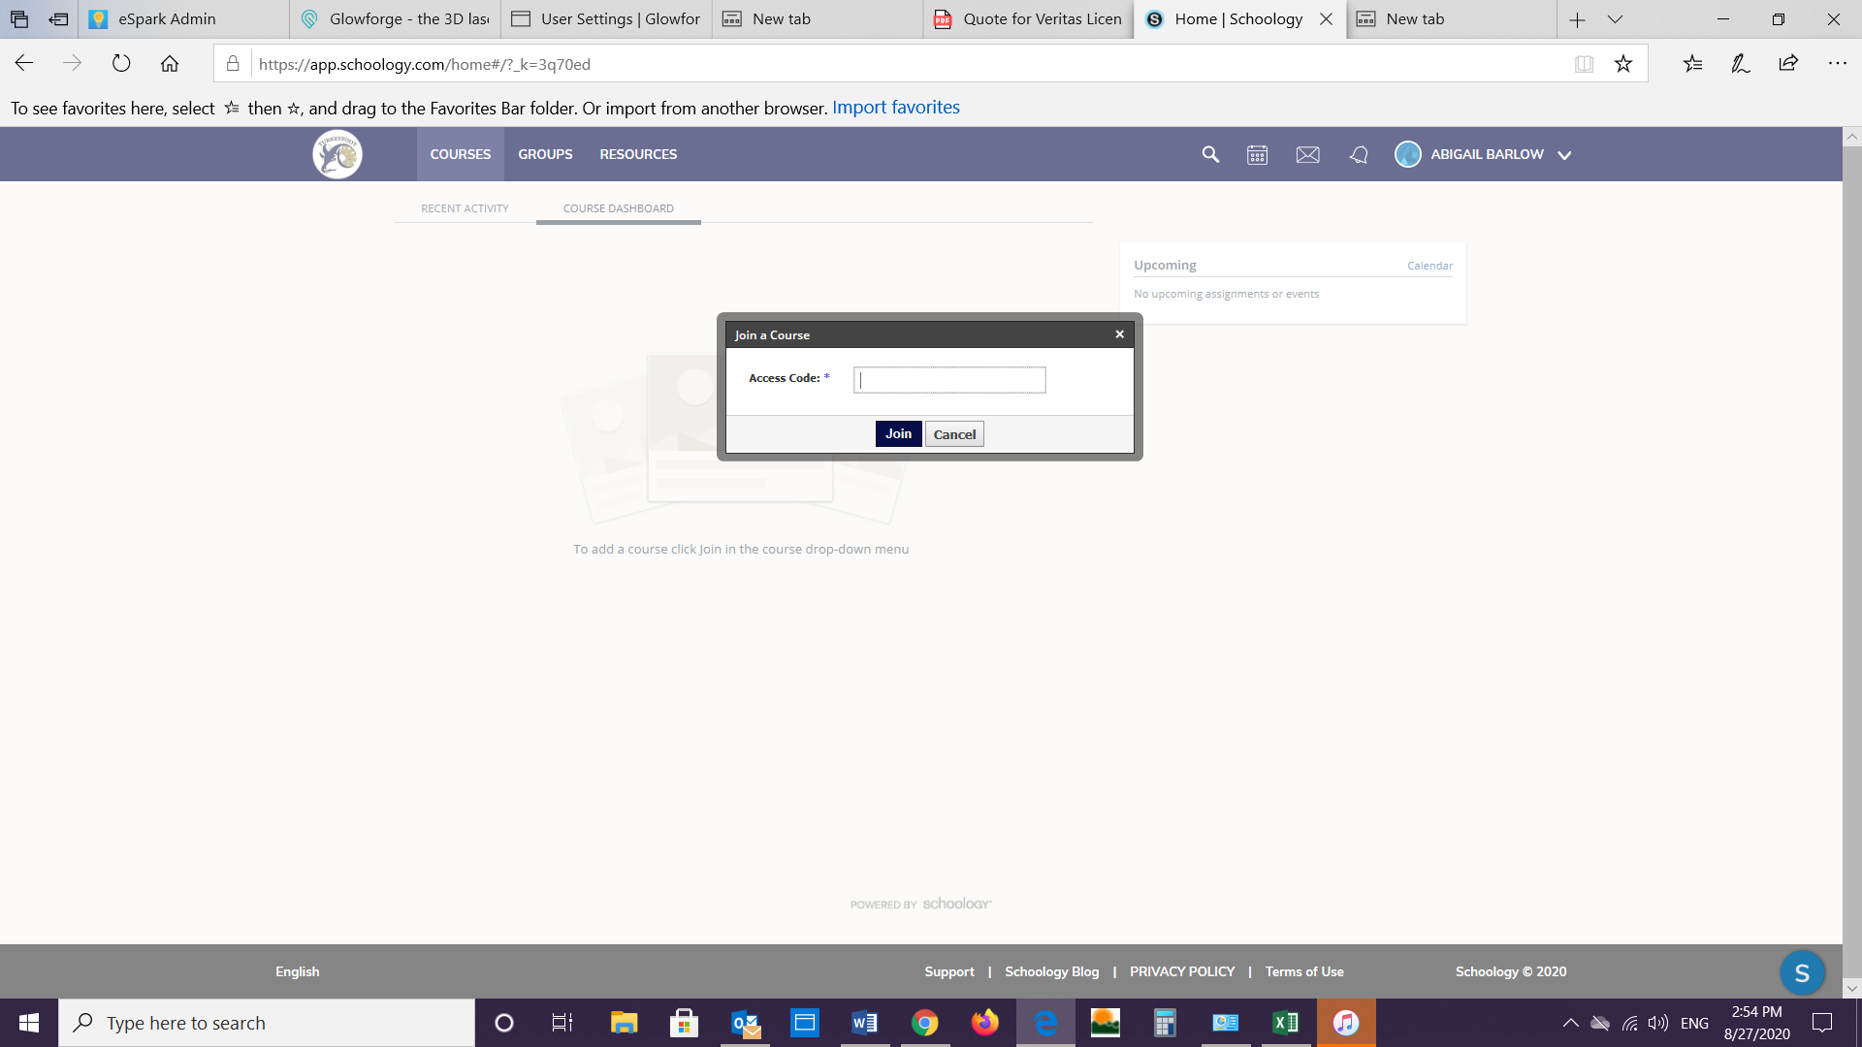

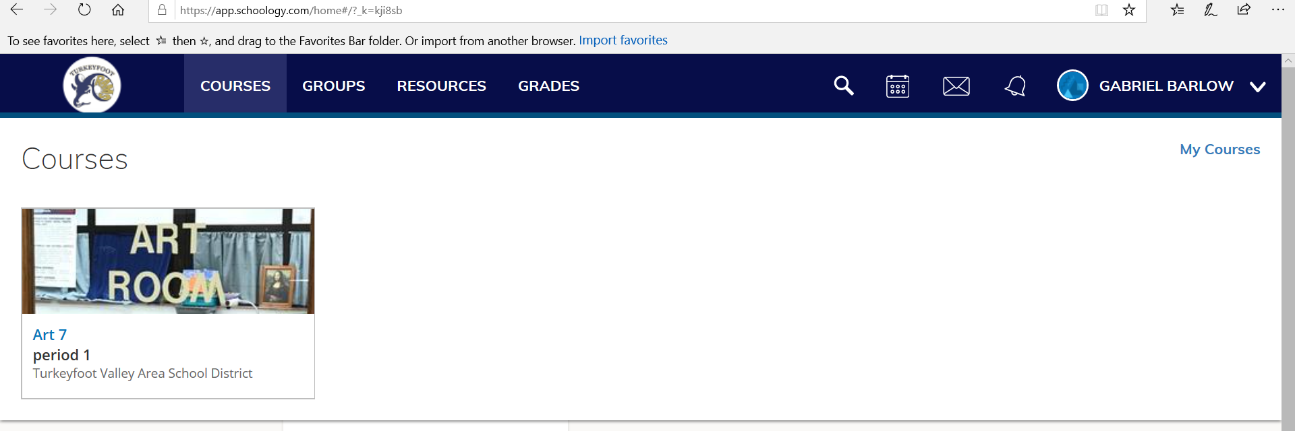
To join another course, click on COURSES again and click the My Courses link to take you to the page where you can join another courses.
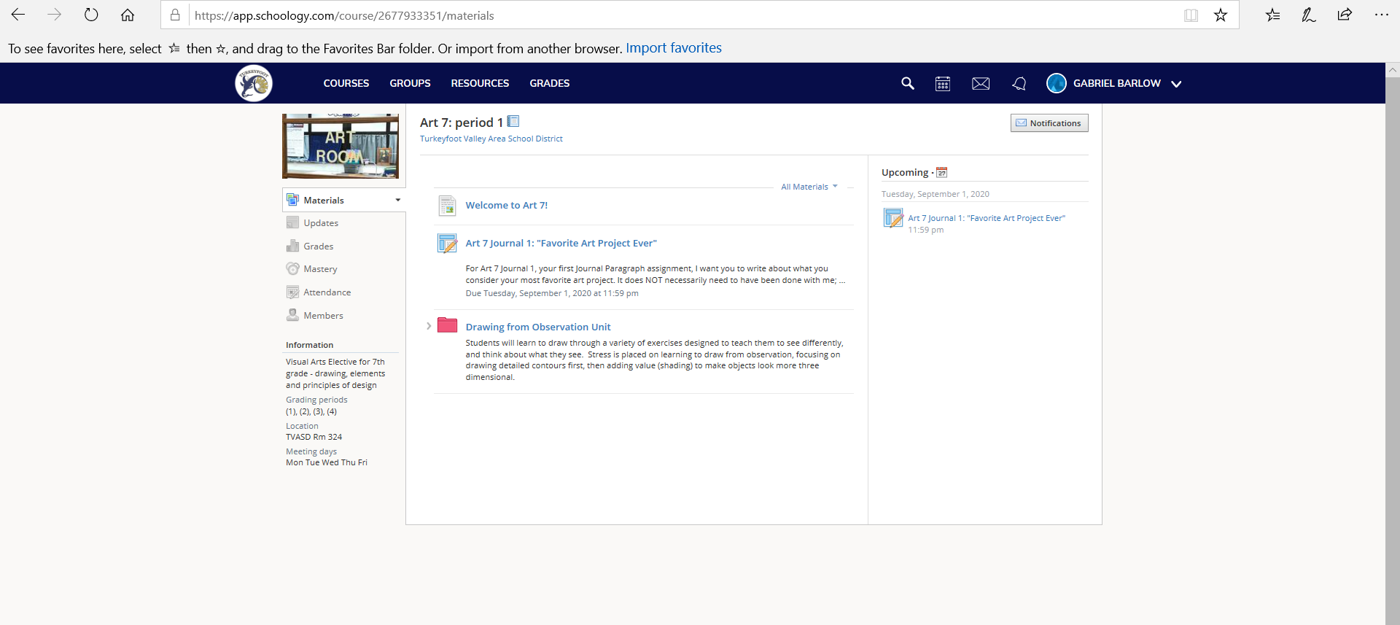
Step 4: At this point you will see you class page. All materials can be accessed from here. You can also send your teacher a message by clicking the envelope in the upper right corner. Type their name and click on it. Send your message. Check here for new messages.
Here you will find instructional materials and assignments.
Click here to send or look at messages.

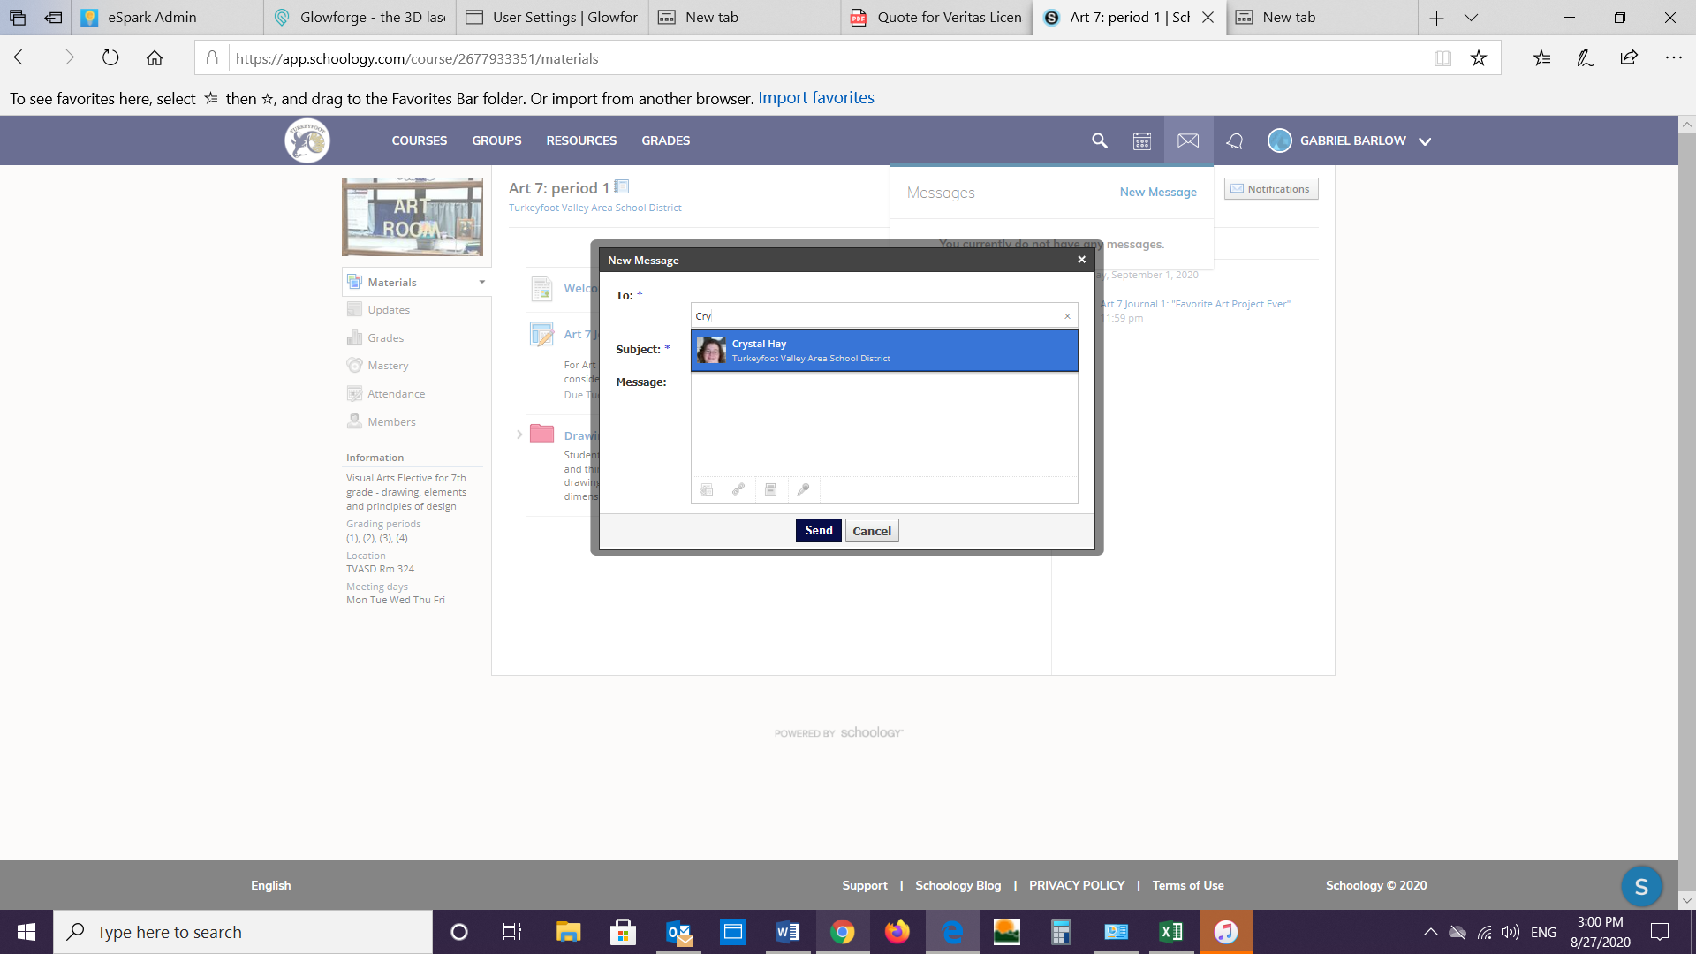
Click your teachers name when it appears. Type your message and send it.

Step 5: To go to a different class, click on COURSES. Feel free to explore more features, but these are the basic steps to get you started. You teachers will have more information for you. If you have questions or need technical support, please contact Mrs. Barlow at the school.

